Introduction to Tank Game 2021

Background/setting
You the player starts out as a student for the army this game is kind of a game within a game where the layer must complete all these training exercises within the game to complete his training for the army. The government have realised that all the skills people are using to play games with slight manipulation can be used to help train a new division of soldiers and so your story begins.
Layout
Level 1 is the first actual level of the game it is based just on the outskirts of a city where the player will have lots of room to practice and further their understanding of the game. They will be able to see the large buildings in the city and be able to drive around in a carpark just outside it. The player will also be able to see a mountain off to the distance this is just to add more appealing graphics to the game and help fill empty spaces.
Level structure
So, Level 0 also known as the tutorial is a very basic plain room that start you off next to a solid wall with a doorway to get through to the next room this is so the player can focus on movement and try learning the size of the vehicle they are driving. Once through the opening bit they will be greeted with a more open area in which they may move around see some textures and practice shooting and aiming. Level 1 is then the first real level of the game, you are put just outside a city with some lovely textures and just off in the distance will be a huge mountain. The player will go around this level finding and destroying all barrels while not destroying any boxes.
Tutorial level
As previously stated, the tutorial is a very basic plain room that start you off next to a solid wall with a doorway to get through to the next room this is so the player can focus on movement and try learning the size of the vehicle they are driving. Once through the opening bit they will be greeted with a more open area in which they may move around see some textures and practice shooting and aiming. This is all very basic as to not overwhelm any new players, of course this is as basic as tutorial level go in terms of teaching you what to do and how to do it.
Colour palette
Blue was used for the glass windows on the building within the city
Grey was used as a basic shade for the floor in the tutorial level
Metallic grey was used for the tank barrel
Rocky grey was used for the mountain
Yellow brown was used for wood
Rusty red was used of barrels
Light grey was used for concrete
Gold was used on bullets
Black was used on tarmac
Dark green was used for grass
Light green was used on the tank
References
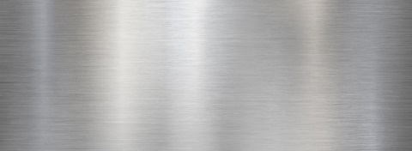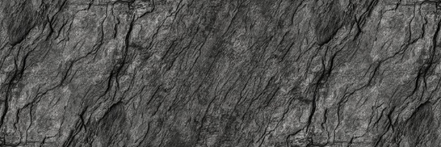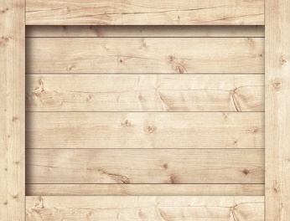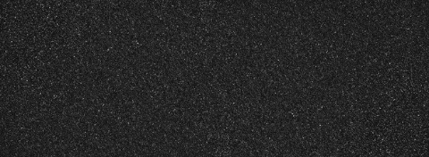
All above images were used as textures in Tank Game 2021 and where from the following website: https://stock.adobe.com/uk

